IMPLEMENTATION PROJECT PLAN

ULTRASONIC NAVIGATION SYSTEM FOR BLIND PEOPLE
IMPLEMENTATION PLAN

02/20/2021

INTRODUCTION

1 Purpose

In our life we meet many disable people, some of them are partially and some are completely disable. The partially impaired people like dumb, and blind manages their life with difficulties and feel separated from others.
Therefore, communication plays a major role and make them feel better and help them to indulge in an activity where they can see themselves as an independent person in public areas.
This will help them in setting up correspondence between Blind/Dumb and the outside world

2. Assumptions and Constraints
I made assumptions regarding the development and execution of this document along with the applicable constraints. Here are some items to consider when identifying the assumptions and constraints:

o Schedule of the project ------------------------------------------------------------------------- 6th Feb to 27th March
o Budget ------------------------------------------------------------------------------------------------------- Rs. 3000 to 5000
o Resource availability and skill sets --------------------------------- Microcontrollers, Sensors, and Coding
o Software and other technology to be purchased ------------ Raspberry-Pi 3 B + Module & Thonny
o Constraints associated with product interfaces ------------------------------- Sensors & Their Protocols

3. Project Materials
  - Raspberry-Pi (System on Chip)
  - PCB Board
  - Vibrating Motor
  - LED Indicators (Optional)
  - Earphones
  - Ultrasonic Sensor
  - Jumper Cables
  - Small Battery (3.2-3.5 V)
  - Switch
  - Handy or Wearable Material
  - Python programming language.

4. Management Overview

Description of Implementation
The planned deployment, installation, and implementation approach for this project is so far that I had brought all the necessary components and material and still working on them.

Points of Contact
This project implementation work is in under the guidance of Prof. Lata Bhatia.
5. Major Tasks

One of the Major task which I have been doing in this IoT project is to actually knowing the need and advancement of system according to the user (Blind Individuals) so that I can make that & implement in my project at affordable production cost of the system.

- Incremental implementation or approach phase
In this phase, I did some normal research about sensors and ARM architecture of Raspberry-Pi through some official research papers of the used system.

- Parallel execution phase
In this phase, I found out and solved the compatibility issues of some sensors with Raspberry-Pi
- One-time conversion and switchover phase
In this phase, with the help of Raspberry- Pi Interface and their updated GUI system created a remote desktop connection so that I can access the system in the unavailability of devices and peripherals

Include the following information for the description of each major task, if appropriate:

- This project will surely accomplish the need of blind individuals
- There is some resources required to accomplish this project including software resources which I am trying to satisfy its requirement.
- The criteria for successful completion of this project is none other than the user acceptance to this project so they can easily cope up with this system.

Consider addressing the changes that may be necessary once the system has been implemented.

6. Hardware
Raspberry-Pi (System on Chip), Bread board, Vibrating Motor, LED Indicator, Earphone, Ultrasonic Sensor Jumper Cable, Small Battery (3.2-3.5 V) Switch, Handy or Wearable Material

7. Software
Python programming language, Thonny python editor, Geany editor (Raspberry-Pi default editor),
Fritzing tool.

8. Performance Monitoring
Since am performing and working on my project I just found one vulnerability related to software part itself
No other hardware vulnerabilities found till the date.

9. Vulnerability

- One of the software vulnerability I found and observed while writing the code and thinking of logic to the code is that python inbuilt Text-to-Speech library (updated version) is not working in python 2 as well as in the latest version of python 3
- After trying it installing and uninstalling few times into the Raspberry- Pi Operating System, still that problem is not resolving
- Library named as Pyttrsx3
- Still am trying to use another library (if present) in python which will help me when the device will be offline during its working as user cannot access internet every time while using this system

10. Progress & Images of the Work done

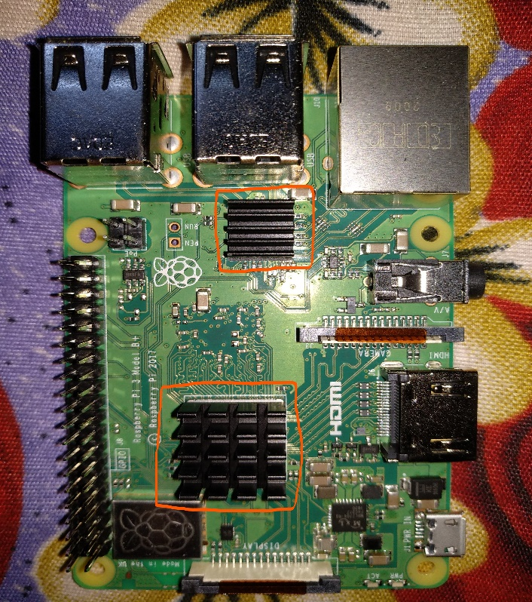

Two heat-sinks are installed on the processor and 1 GB RAM of the Raspberry-Pi Module to avoid the heat liberation of the system while working.

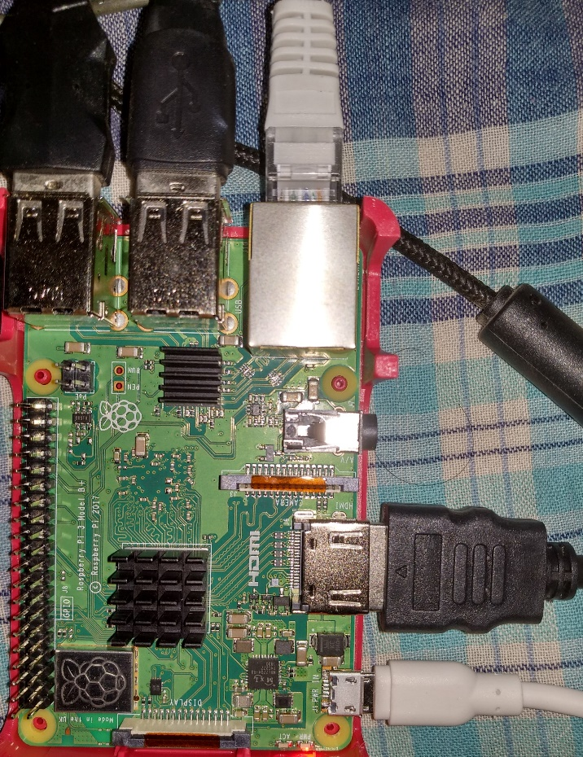

All necessary interfaces and plug-ins connected to the Raspberry-Pi Module,
- 2 USB keyboard & Mouse Inputs
- 1 Ethernet plugin to access the internet at a time of booting up process.
- 1 HDMI (High-Definition Multimedia Interface) for interfacing monitoring screen to the system.

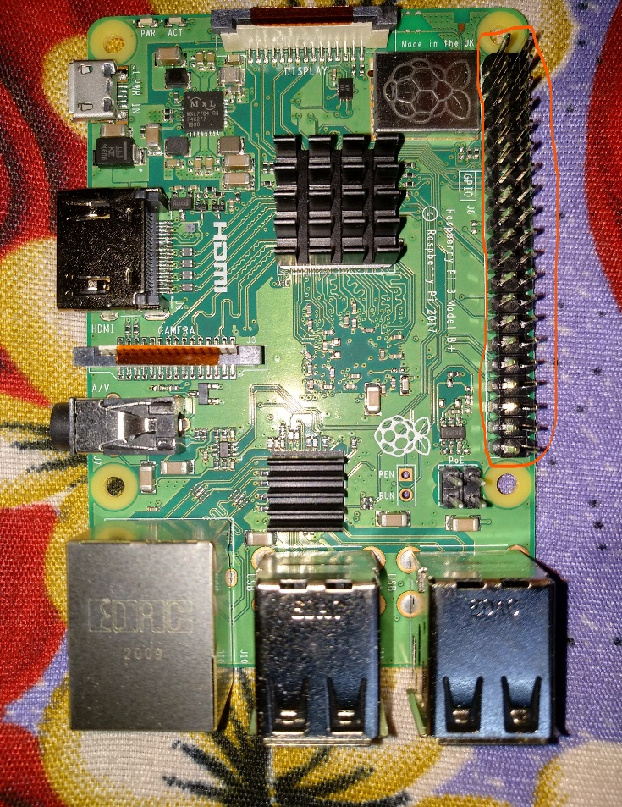
11. Detailed description of GPIO pins of Raspberry-pi Module

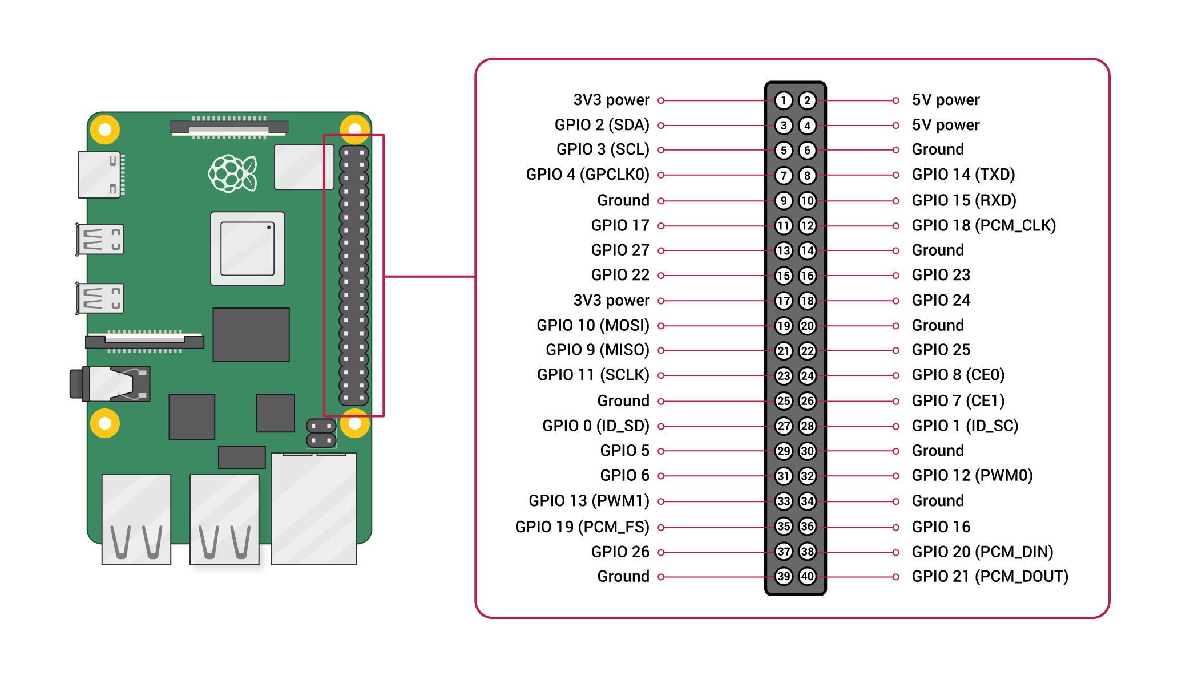

12. Boot-up process of operating system

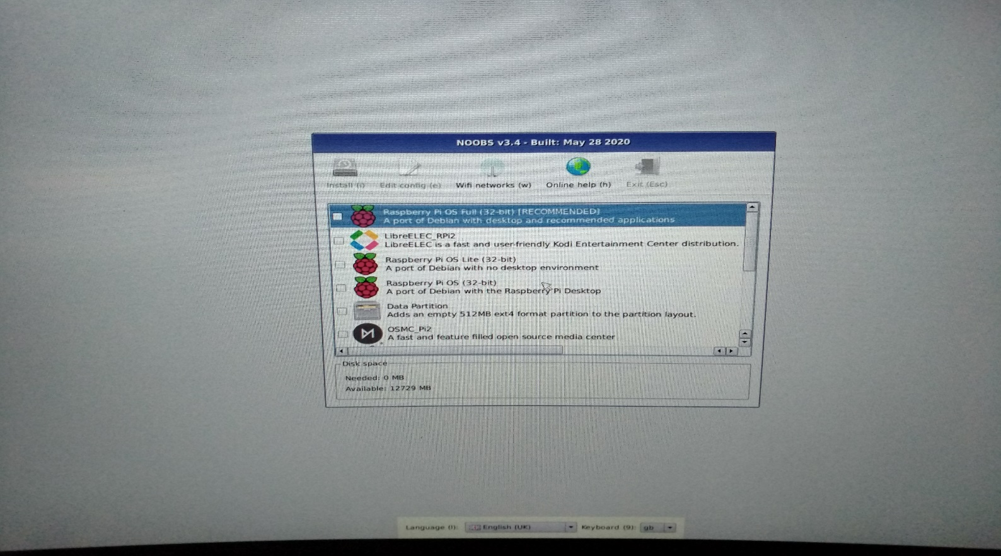

Selecting a port of debian with recommended full version of Raspberry-Pi.
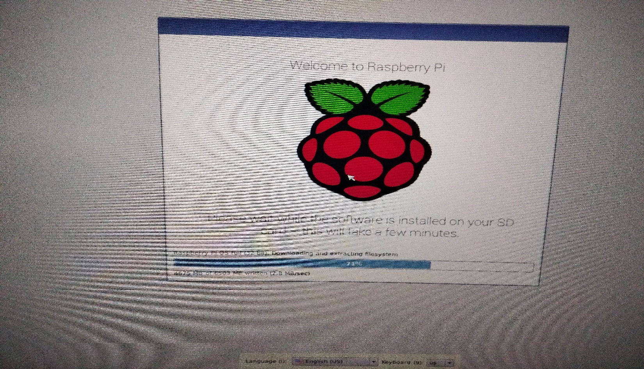

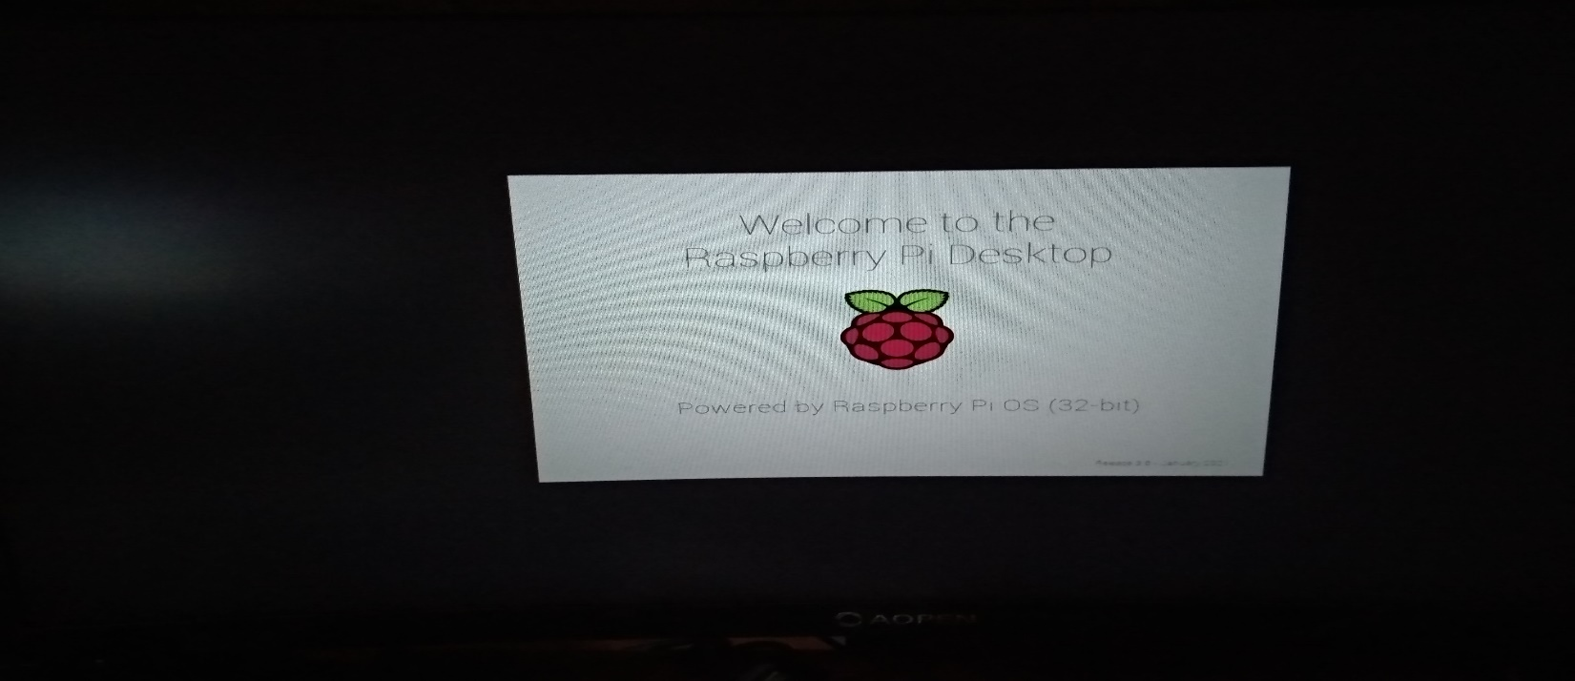

Welcome screen of Raspberry-Pi Desktop version. (32-bit)

13. Working on Coding part:

import RPi.GPIO as GPIO
import time
pulse start = 0

GPIO.setmode(GPIO.BOARD)

trigger = 12
echo = 30

while 1:

GPIO.setmode(GPIO.BOARD)
print ("detecting distance....")
GPIO.setup(trigger,GPIO.OUT)
GPIO.setup(echo,GPIO.IN)

GPIO.output(trigger, False)
print ("let the sensor to be stable")
time. Sleep (1)

GPIO.output(trigger, True)
time. Sleep (0.000001)
GPIO.output(trigger, False)

while GPIO.input(echo)==1:
pulse end = time. Time ()

pulse duration = pulse end - pulse start

distance = pulse duration * 17150

distance = round (distance, 2)

print ("Distance:”, distance, "cm")
if distance <= 15:
print("alert")

time. Sleep (2)

GPIO.cleanup()

For LED Blinking:

import RPi.GPIO as GPIO
import time
GPIO.setmode(GPIO.BOARD)
GPIO.setwarnings(False)
GPIO.setup(3, GPIO.OUT)
while True:
GPIO.output(3, True)
time. Sleep (0.50)
GPIO.output(3, False)
time. Sleep (0.50)
*** Here am using GPIO.setmode line to avoid the garbage warnings from GPIO interface.***
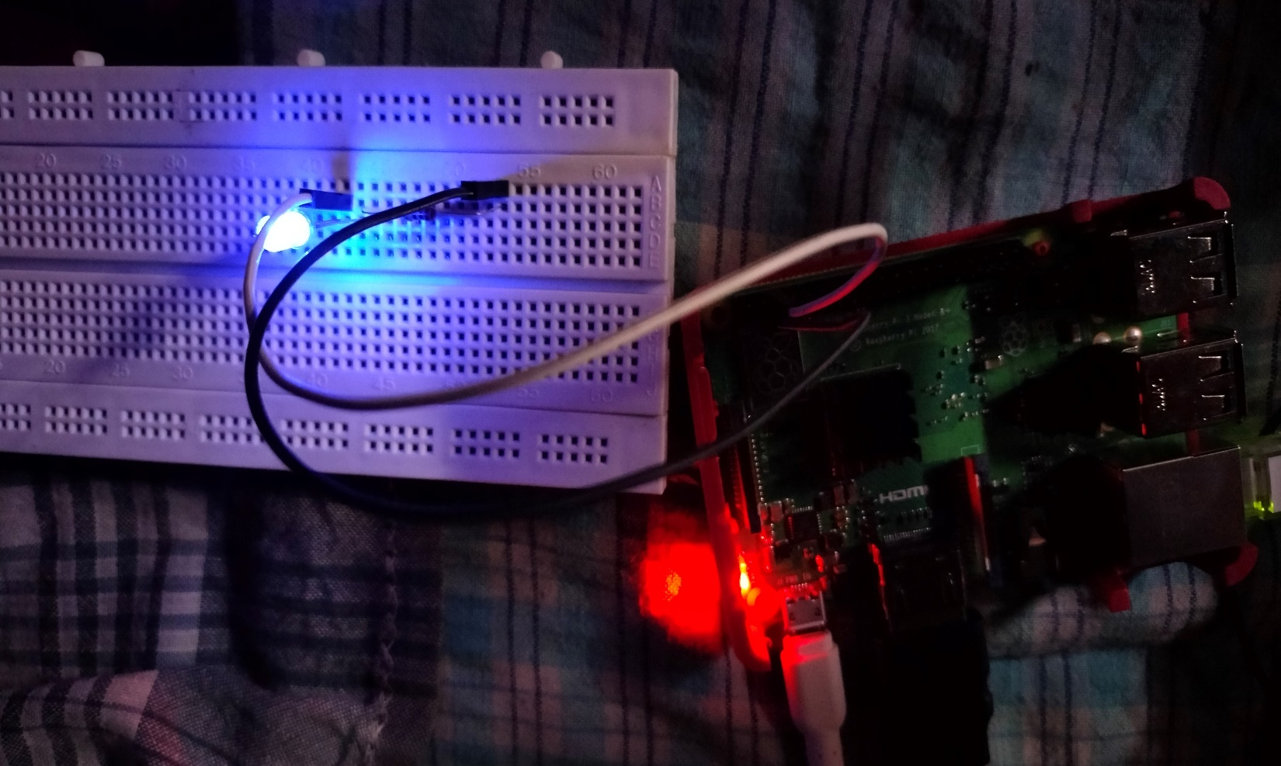

Image of LED indicator blinking.

14. References

Some official research papers of previously done IoT projects and information regarding sensors through IEEE research papers

15. Project Implementation Plan Approval

The undersigned acknowledge that they have reviewed the “Ultrasonic Navigation System for Blind People” Implementation Plan and agree with the information presented within this document. Changes to this Project Implementation Plan will be coordinated with, and approved by, the undersigned, or the designated guide.

THANK YOU

